Assignment 7

Name: Mohanish Khambadkar

Roll No.: 207

Division: C

Batch: C3

Problem Statement:

Write a program in C++ to implement the following probabilistic data structures: Bloom’s Filter,  
[Cuckoo Filter](http://moodle.mitaoe.ac.in/mod/resource/view.php?id=61083).

**CODE:**

#include<iostream>

#include<bits/stdc++.h>

#include<string>

using namespace std;

#define MAX 100

class bloom{

public:

int m;

string arrin[MAX];

int arr[MAX];

bloom()

{

for (int i = 0; i < MAX; i++)

{

arr[i] = 0;

}

}

void input();

void bloomwork();

};

class cuckoo

{

public:

int c1[10],c2[10],num;

cuckoo()

{

for(int i=0;i<10;i++)

{

c1[i]=c2[i]=0;

}

}

void insert(int num,int size);

void display(int size);

};

void bloom::input()

{

cout<<"Enter the no of string"<<endl;

cin>>m;

cout<<"Enter the string char"<<endl;

for (int i = 0; i < m; i++)

{

cin>>arrin[i];

}

}

void bloom::bloomwork()

{

for (int i = 0; i < m; i++)

{

int hash1= 0;

string s = arrin[i];

for (int j = 0; j < s.size(); j++)

{

hash1 = hash1+int(s[j]);

}

int h1 = (2*hash1)%m;

int h2 = ((hash1/2)+3)%m;

arr[h1] = 1;

arr[h2] = 1;

}

for (int i = 0; i < m; i++)

{

cout<<arr[i]<<endl;

}

}

void cuckoo::insert(int num,int size)

{

int a=num%size;

if(c1[a]==0)

{

c1[a]=num;

}

else

{

int temp;

temp=c1[a];

c1[a]=num;

int b=((temp/size)%size);

if(c2[b]==0)

{

c2[b]=temp;

}

else

{

insert(temp,size);

}

}

display(size);

}

void cuckoo::display(int size)

{

cout<<endl<<"Hashtable 1 : ";

for(int i=0;i<size;i++)

{

cout<<c1[i]<<" ";

}

cout<<endl<<"Hashtable 2 : ";

for(int i=0;i<size;i++)

{

cout<<c2[i]<<" ";

}

cout<<endl;

}

int main()

{

bloom obj;

cuckoo c;

int ch;

do

{

cout<<"\n1.Bloom Filter\n2.Cuckoo Filter\n3.Exit\nEnter your choice: ";

cin>>ch;

switch(ch)

{

case 1:

{

obj.input();

cout<<"\n";

cout<<"Final Hash Table"<<endl;

obj.bloomwork();

break;

}

case 2:

{

int a=1;

while(a==1)

{

int num;

cout<<"\nEnter number to be inserted: ";

cin>>num;

c.insert(num,10);

cout<<"\nTo insert more enter 1 else 0: ";

cin>>a;

}

break;

}

default:

{

break;

}

}

}while(ch!=3);

}

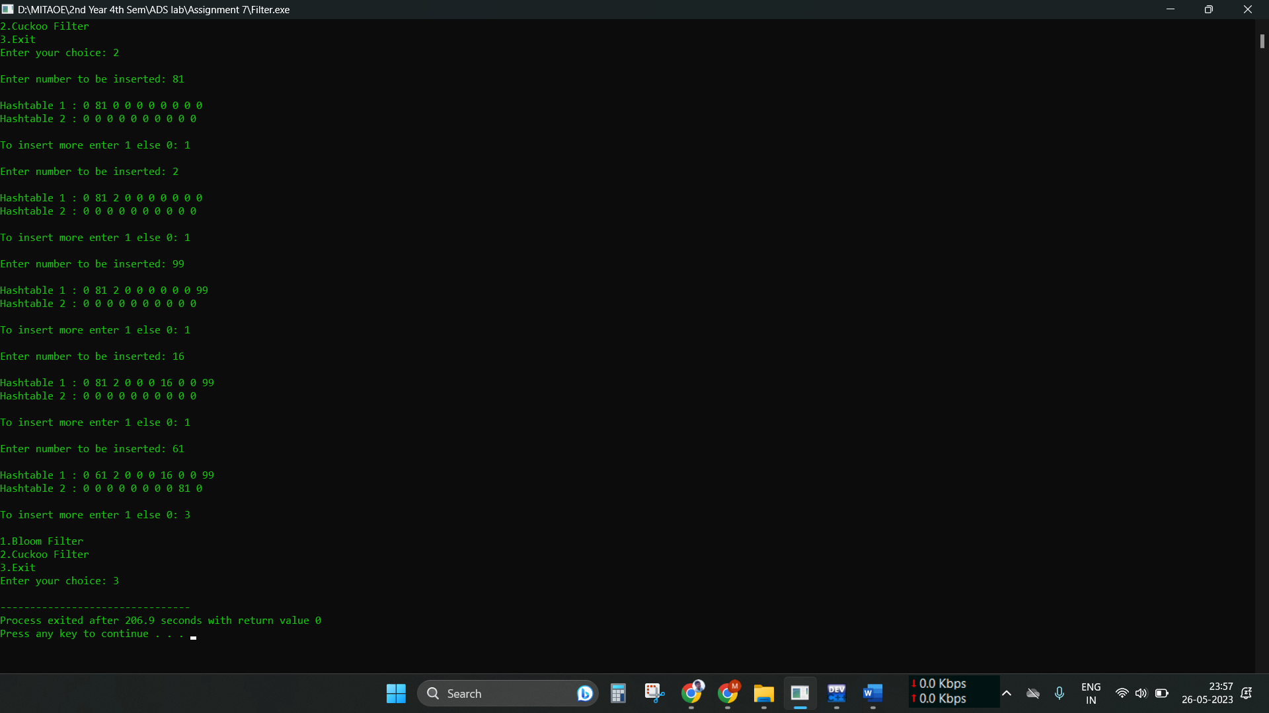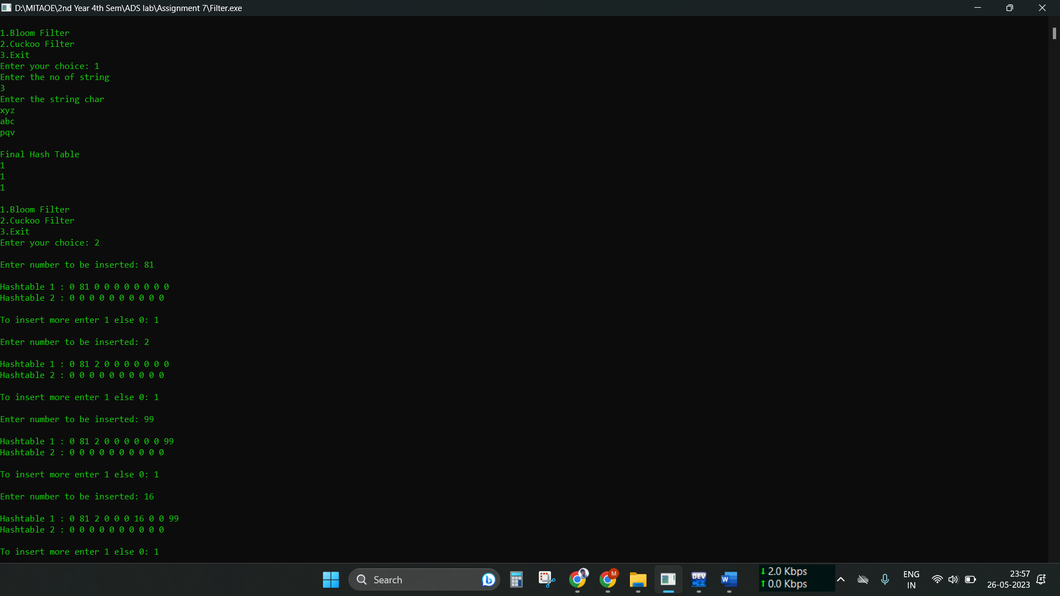Output: